SecureNet Stage 3

Distributed Systems Problems, Service Behavior, and Request Walkthroughs

Part 1: Distributed Systems Problems
This section identifies each distributed systems problem present in SecureNet, where it occurs in the system, and how it is addressed.

1. Leader Election
The problem. Some operations cannot safely run on multiple nodes simultaneously. When multiple nodes could each act as coordinator, conflicting actions produce inconsistent states that are difficult or impossible to reconcile. A mechanism is needed for a group of nodes to agree on which single node is currently in charge, and to recover automatically when that node fails.

Where it occurs.
- The Notification Service requires one node to run the push-notification retry sweeper. If every node ran the sweeper simultaneously, homeowners would receive duplicate alerts.
- The Event Processing Service (EPS) requires one node to own the Lamport sequence counter. If two nodes assigned sequence numbers concurrently they could issue the same number to different events, breaking total ordering.
- PostgreSQL requires one node to act as the write primary. If multiple standbys promoted themselves simultaneously they would each accept conflicting writes.

How we solve it.
- The Notification Service cluster uses a ZooKeeper-style FastLeaderElection algorithm. The cluster uses an odd number of nodes (3 or 5) so that in any network partition at most one side can achieve majority, preventing split-brain.
- The EPS cluster uses Raft's RequestVote election, which additionally enforces a log-completeness requirement so a candidate can only win if its log is at least as up to date as a majority of nodes. This ensures the new EPS leader always has all committed events.
- PostgreSQL uses its own built-in promotion mechanism, which promotes the standby with the highest WAL replay position.

2. Raft Log Replication
The problem. The EPS leader assigns sequence numbers to accepted events, but if it is the only node that holds this data, a single crash loses everything. The data must be replicated to other nodes in a way that guarantees committed entries are never lost even through multiple failures, and that all replicas end up with identical logs in the same order.

Where it occurs. The Event Processing Service maintains an ordered event log that is the authoritative source of truth for security event sequencing. Every entry in this log must survive node failures and must be identical across all EPS replicas so that history queries routed to any replica return consistent results.

How we solve it. The EPS uses Raft log replication. When the leader receives a new security event it appends the entry to its own log and sends an AppendEntries RPC to both followers in parallel. Each follower performs a consistency check -- it only accepts the new entry if its own log agrees with the leader's log up to that point. The leader marks the entry committed only after a majority of nodes (2 of 3) have acknowledged it. Entries from previous terms are never committed directly, they become committed only as a side effect of committing a new entry in the current term. This rule, combined with the log-completeness voting rule, guarantees that no committed entry is ever lost when leadership changes.

3. Load Balancing
The problem. A single instance of any service is a single point of failure and a throughput bottleneck. As request volume grows, no single node can handle the load. Multiple instances must be able to serve requests concurrently, and traffic must be distributed across them with unhealthy instances automatically removed from rotation

Where it occurs. The API Gateway, Device Management Service, User Management Service, Device Firmware Service, and Video Streaming Service are all stateless with respect to request handling. Their mutable state lives in PostgreSQL, so any instance can serve any request. These services need to scale horizontally without coordination.

How we solve it. Each stateless service runs as multiple identical instances behind a load balancer. The load balancer distributes traffic using round-robin for the API Gateway, User Management Service and Device Management Service. The Video Streaming Service uses sticky sessions per stream so that the same client always hits the same instance for the duration of a stream session, avoiding the overhead of re-establishing state. The load balancer performs HTTP health checks on all instances and stops routing traffic to any instance that fails to respond. No leader election is needed because there is no shared mutable state requiring coordination.

4. Cluster Manager and Failure Detection
The problem. Nodes in a distributed cluster fail silently and they do not announce their departure. The remaining nodes must detect failures quickly enough to trigger recovery, without generating so many false positives that the system is constantly in an unnecessary recovery state. Beyond detection, someone must be responsible for starting clusters up, monitoring their health continuously, and replacing failed nodes so the cluster returns to its target size.
Where it occurs. Every cluster in SecureNet needs failure detection and lifecycle management. The EPS Raft cluster and Notification Service ZooKeeper cluster need to detect leader failure and trigger election. The load-balanced clusters for the API Gateway, User Management Service, Device Management Service, Device Firmware Service, and Video Streaming Service need to detect when an instance goes down and remove it from the rotation, then bring up a replacement to restore capacity.
How we solve it. Each node in a stateful cluster sends heartbeat messages to its peers at a fixed interval. Each peer maintains a countdown timer that resets on each valid heartbeat. If the timer expires, the peer marks the silent node as SUSPECTED and starts a countdown. If the node is still silent after a configurable timeout it is marked FAILED. For the Notification Service cluster, the cluster manager maintains a ConcurrentHashMap of peers keyed by node ID, each entry holding host, port, last heartbeat timestamp, and liveness status. A FAILED node is removed from the active view through the membership change protocol so it no longer counts toward quorum. For the EPS Raft cluster, a FAILED leader causes followers to time out and start a Raft election; a FAILED follower is simply excluded from quorum calculations until it recovers.
Sitting above all of this is a dedicated Cluster Management Service. This service starts up all clusters on system initialization, registers each node with its cluster, and continuously monitors the health of both stateful clusters and load-balanced instance pools. When it detects that a node in a stateful cluster has been marked FAILED, it creates a replacement node and runs the membership change protocol to add it back to the cluster, keeping the cluster at its target odd size. When it detects that a load-balanced instance has gone down, it starts a replacement instance and registers it with the load balancer. The Cluster Management Service is itself stateless and runs as multiple instances behind a load balancer so it is not a single point of failure.

5. Quorums
The problem. In a replicated system, writes must reach enough nodes that any future read is guaranteed to overlap with at least one node that saw the write. If writes only reach one node, that node's failure loses the data. If reads only contact one node, they might miss the latest write. A quorum is the minimum number of nodes that must participate in an operation before it is considered complete.

Where it occurs. Leader election requires a quorum of votes before a winner can be declared. Log replication requires a quorum of acknowledgements before an entry can be committed. Both are present in the EPS Raft cluster and the Notification Service election cluster.

How we solve it. All SecureNet clusters use a strict majority quorum: floor(N/2) + 1 nodes must agree. For a 3-node cluster this is 2. This threshold guarantees that any two quorums overlap by at least one node, so a write that reached quorum will always be seen by any subsequent quorum read. Clusters are always sized with an odd number of nodes so that in any partition exactly one side can achieve majority. The quorum threshold is computed from the last acknowledged view size, not from the number of currently reachable nodes, to prevent a partitioned minority from falsely reaching quorum by redefining N as the number of nodes it can see.

6. Data Replication
The problem. All persistent state like device records, user accounts, event history, push tokens, and video metadata must survive the failure of any single database node. A single PostgreSQL instance is a single point of failure. Reads must remain available even when the primary is under heavy write load.

Where it occurs. The Data Storage Layer is shared by all SecureNet services. Every write from the Device Management Service, User Management Service, Event Processing Service, and Notification Service goes to PostgreSQL. A primary failure without replication would take the entire platform down.

How we solve it. PostgreSQL runs as one primary and two standbys using built-in Write-Ahead Log streaming replication.

7. Lamport Clocks
The problem. IoT devices have local clocks that drift. A motion sensor might report an event timestamp that is 30 seconds behind or ahead of wall clock time. If the EPS orders events purely by their device-local timestamps, events from different devices can appear in the wrong order, causing automation rules to fire incorrectly,for example, a door-unlock event appearing to precede a motion event when in reality it followed it.

Where it occurs. The Event Processing Service must assign a total ordering to all incoming security events before they are stored and evaluated against automation rules. Events arrive from many different IoT devices, each with its own potentially drifting clock.
How we solve it. The EPS leader maintains a Lamport logical clock. When an event arrives with device timestamp D, the leader sets its clock L = max(L, D) + 1 and assigns L as the event's sequence number. This ensures the EPS ordering is always at least as recent as any device timestamp it has seen, and that no two events ever receive the same sequence number. Automation rules compare sequence numbers, not device-local timestamps. The device-local timestamp is still stored in the event record for display purposes so homeowners see when the event actually occurred on the device, but it plays no role in ordering or rule evaluation.

8. Idempotency
The problem. Any network call can fail ambiguously and the sender cannot know whether the receiver processed the request and crashed before responding, or whether the message was lost in transit. If the sender retries, the operation might execute twice. In a security system, executing an event twice means storing a duplicate event in the history and potentially firing a duplicate alert.

Where it occurs. IoT device firmware retries failed HTTP posts to the EPS when no 202 response is received within a certain interval. The Notification Service retries failed APNs/FCM dispatches through its retry sweeper.

How we solve it. For device-to-EPS event ingestion, each publishEvent call includes an idempotency key computed as a hash of the deviceId, eventType, occurredAt timestamp, and a per-device sequence nonce stored in flash. The EPS maintains a deduplication table keyed on this hash with a 24-hour TTL. If a retried event arrives with a key already in the table, the EPS returns the original 202 response without creating a duplicate entry. For the Notification Service, each pending notification row has a UUID that is set as the APNs apns-id header and the FCM collapse-key. APNs and FCM deduplicate on these keys at the platform layer, so a retried dispatch does not produce a duplicate notification on the homeowner's device.

9. CAP Theorem
The problem. The CAP theorem states that a distributed system cannot simultaneously guarantee consistency, availability, and partition tolerance. Since network partitions are unavoidable in any real deployment, every system must choose, per operation, whether to favour consistency (every read returns the latest write) or availability (every request gets a response) when a partition occurs. Making the wrong choice for an operation has serious consequences: choosing availability for a lock command could tell a homeowner their door is locked when it is not; choosing consistency for event history means the app shows an error when the history database replica is temporarily unreachable.

Where it occurs and how we decide. SecureNet makes different choices for different operations based on the cost of getting it wrong.
- Lock and unlock commands choose consistency. If the Device Management Service cannot read the device's current status from the primary database, the command is rejected with a 503 rather than proceeding on potentially stale data. Telling a homeowner their door is locked when it is not is unacceptable.
- Token validation chooses consistency. The API Gateway always validates tokens against the primary database. Accepting a revoked token is a security breach so a stale read is never acceptable here.
- Event ingestion chooses consistency. The EPS leader does not acknowledge an event until it is committed on a Raft quorum. No confirmed event is ever lost even if the leader crashes immediately after responding.
- Event history queries choose availability. Serving slightly stale history from a replica is harmless to the homeowner. Queries go to the asynchronous standby and fall back to the primary only if the standby is unreachable.
- Push notification delivery chooses availability with at-least-once semantics. A duplicate notification is far less harmful than a missed security alert. The retry sweeper keeps retrying failed dispatches and idempotency keys at the APNs/FCM layer prevent the homeowner from seeing duplicate notifications on their device.
- Device heartbeat recording chooses availability. A missed heartbeat write is not critical because the device will send another heartbeat within 30 seconds. Writes go to a write buffer that tolerates brief primary unavailability rather than blocking the device.

Part 2: Request Walkthroughs

Request 1: Device Onboarding
Content of request: Owner ID (from authenticated session), device type, QR code payload or manually entered device ID.
Desired response: Device appears in the homeowner's dashboard with status ONLINE. Device has downloaded the latest firmware and is ready to operate.

Happy Path:
The homeowner opens the Client Application and taps Add Device. The following steps trace the request through each service.
- Client Application prompts the homeowner to scan the device QR code. It validates the QR code format locally. If the format is invalid, it offers manual device ID entry. Once a valid ID is obtained, the app sends a device registration request to the API Gateway over HTTPS, including the owner's bearer token and the QR payload.
- API Gateway receives the request and calls validateToken() on the User Management Service to authenticate the bearer token. On success it routes the request to the Device Management Service.
- User Management Service verifies the JWT signature and expiry without a database round trip, then checks the revocation list. Returns a valid AuthToken to the gateway.
- Device Management Service parses and verifies the QR payload. It checks the Data Storage Layer to confirm the device is not already registered. It creates a device record with status PENDING_REGISTRATION, generates MQTT credentials, and persists both to the Data Storage Layer. It returns the device ID to the gateway which forwards it to the Client App.
- IoT Device Firmware powers on and connects to WiFi with exponential backoff. Once connected, it posts its QR one-time token to the IoT Device Firmware service over HTTPS. The IoT Device Firmware service forwards the registration call to the Device Management Service, which completes the handshake, transitions the device to ONLINE, and returns DeviceCredentials to the firmware service, which passes them back to the physical device.
- IoT Device Firmware uses the returned credentials to open a MQTT connection to the broker and subscribes to its command topic. It then requests the latest firmware from the IoT Device Firmware service. The firmware service retrieves the firmware from the Device Management Service and streams it over MQTT to the device. The device installs the firmware, and confirms its online status.
- Device Management Service marks the device ONLINE in the Data Storage Layer and notifies the Client Application.
- Client Application displays the device in the homeowner's dashboard. Onboarding is complete.

Problems at each step
Step 1) Client Application: QR scan and registration request
- QR code cannot be scanned. The app falls back to manual device ID entry. The entered ID is validated against the expected format before the request is sent.
- Client has no network connectivity. The registration request fails immediately. The app shows an error and prompts the user to check their connection. No partial state is created.
- User submits the same request twice by tapping the button twice quickly. The Client App assigns a correlation ID to the registration request. The API Gateway's deduplication cache returns the cached result on the second submission without forwarding a duplicate request to the Device Management Service.
DS issues: Idempotency; correlation ID prevents duplicate device registration requests.

Step 2) API Gateway: routing
- The API Gateway instance handling the request crashes mid-flight. The load balancer detects the failure via health checks and routes the client's retry to a healthy instance. Because the DMS had not yet created the device record, no partial state exists and the retry is safe.
- All API Gateway instances and/or DFS are unhealthy. The load balancer returns 503. The client shows an error. The Cluster Management Service detects the outage and starts replacement instances.
DS issues: Load Balancing; multiple API Gateway instances behind a load balancer prevent single-node failure from blocking all registrations.

Step 3) User Management Service: token validation
- Token is expired or malformed. UMS returns 401. The gateway forwards 401 to the client, which prompts the homeowner to log in again.
- Token has been revoked (user logged out on another device). The revocation list check catches this. Returns 401.
- UMS primary database is unreachable for revocation list check. Token validation chooses consistency and the request is rejected with 503 rather than accepting a potentially revoked token. The homeowner retries when the service recovers.
DS issues: CAP Theorem; token validation chooses consistency. A stale read here would be a security breach.

Step 4) Device Management Service: registration
- QR payload verification fails. The device ID is counterfeit or the QR code was tampered with. DMS returns 400 InvalidQRPayload. The client shows an error and offers manual entry.
- Device is already registered to the same owner. DMS returns the existing device record. The client treats this as success and shows the device in the dashboard.
- Device is already registered to a different owner. DMS returns 409 DeviceAlreadyRegistered. The client shows an error telling the homeowner to contact support.
- Data Storage Layer primary is unavailable when writing the device record. The write fails. DMS returns 503. The client retries with the same correlation ID. Because no record was written on the first attempt, the retry is safe and creates the record cleanly.
DS issue: Data Replication; the write goes to the PostgreSQL primary. If the primary is down during failover, the Cluster Management Service promotes the synchronous standby within seconds and the retry succeeds.
DS issue: Idempotency; the correlation ID on the registration request ensures a retry does not create two device records.

Step 5) IoT Device Firmware: WiFi connection and cloud registration
- WiFi connection fails repeatedly (wrong password, weak signal). The firmware retries with exponential backoff (1 s, 2 s, 4 s up to 64 s). The app shows troubleshooting steps to the homeowner.
- The registerWithCloud() POST reaches the IoT Device Firmware service but the response is lost in transit. The device retries the POST. The DMS idempotency check on the QR token detects the duplicate and returns the already-created DeviceCredentials without creating a second record.
- The device powers off mid-registration before completing the handshake. The device record stays in PENDING_REGISTRATION state. When the device powers back on it resumes from the registerWithCloud() call. The DMS handles re-registration of a PENDING device as a continuation of the same flow.
DS issue: Idempotency; the QR token is a one-time idempotency key. Retried registration calls return the same credentials without side effects.

Step 6) IoT Device Firmware: MQTT connection and firmware download
- MQTT broker is temporarily unreachable. The firmware retries with exponential backoff. Commands sent to the device during this window are queued on the broker and delivered when the connection is established.
- Firmware download is interrupted. The device retries the download. The firmware binary is versioned and integrity-checked with a checksum. If the checksum fails the device discards the partial download and retries from the beginning.

Step 7) Device Management Service: mark device ONLINE
- The ONLINE status write to the Data Storage Layer fails. DMS retries the write up to 3 times with backoff. If all retries fail, the device remains in PENDING_REGISTRATION in the DB but is functionally operational. The next heartbeat from the device triggers recordHeartbeat(), which transitions the status to ONLINE as a self-healing mechanism.
DS issue: Cluster Manager and Failure Detection; the heartbeat mechanism acts as a self-healing reconciliation path for missed status transitions.

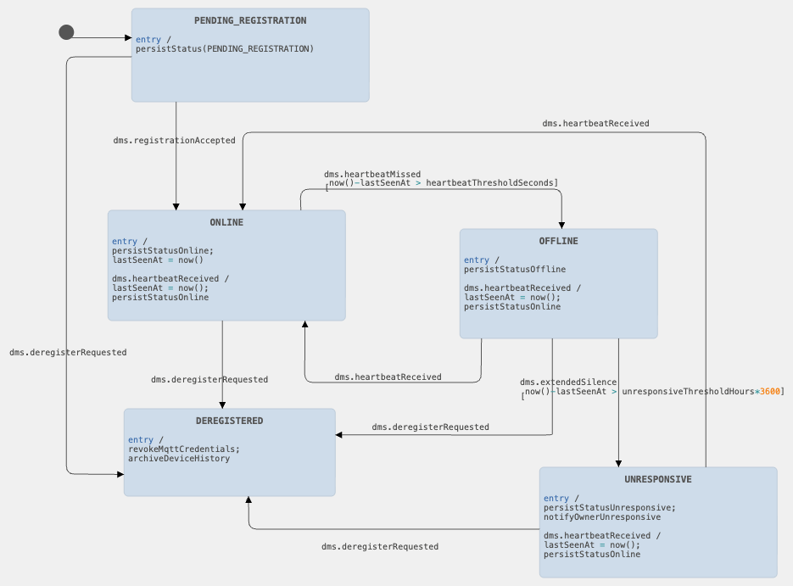
Device_record_state_chart

Request 2: Remote Door Lock
Content of request: deviceId, command (LOCK or UNLOCK), bearer token.
Desired response: Confirmation that the physical lock has executed the command and the new lock state is reflected in the app.

Happy Path:
- Client Application sends sendLockCommand(deviceId) to the API Gateway over HTTPS with the bearer token.
- API Gateway validates the token via the User Management Service. On success, routes the request to the Device Management Service.
- Device Management Service reads the device record from the Data Storage Layer primary to confirm the device is ONLINE. It then calls the IoT Device Firmware service, instructing it to send a LOCK command to the specific device. The firmware service publishes the LOCK command with the correlationId to the device's MQTT topic.
- IoT Device Firmware receives the LOCK command via its MQTT connection. It engages the lock motor, polls the lock-state sensor to confirm the locked state, and publishes an acknowledgement containing the correlationId and new lock state to the device's response MQTT topic. The IoT Device FirmWare Service receives the ack and sends success to the DMS
- Device Management Service receives the sucess, writes the updated lock state to the Data Storage Layer, and returns success to the API Gateway.
- API Gateway forwards the success response to the Client Application, which updates the UI to show Locked.

Problems at each step
Step 1) Client Application: sending the command
- The user taps Lock twice quickly. The Client Application assigns a correlationId to the command at creation time. The API Gateway deduplication cache absorbs the duplicate and returns the cached result without forwarding a second command to the DMS.
- Two family members send conflicting commands simultaneously. The DMS serializes all commands to a given device through a per-device lock. The first command to acquire the lock executes and the second waits. Both users receive an accurate final state.
DS issue: Idempotency: correlationId prevents double execution of the same command. Per-device lock serializes concurrent conflicting commands.

Step 2) API Gateway: token validation and routing
- Token is expired or revoked. UMS returns 401. Gateway forwards 401 to the client. The user is prompted to log in again.
- All DMS instances are unhealthy. Gateway returns 503. The Cluster Management Service detects the outage and restores capacity. The client retries.
DS issue: Load Balancing: multiple DMS instances behind the load balancer. CAP Theorem token validation always reads from the primary.

Step 3) Device Management Service: status check and MQTT publish
- Device status is OFFLINE or UNRESPONSIVE. DMS reads the device record from the primary and sees a non-ONLINE status. It immediately returns DeviceOfflineException without publishing the MQTT command. The client shows an error. No command is sent to a device that cannot receive it.
- Device status is ONLINE in the DB but the device went offline between heartbeats. The DMS publishes the command but receives no ack within the timeout window (Step 4). The timeout handler catches this.
- MQTT broker is unreachable. The IoT Device Firmware service catches the publish exception and returns an error to the DMS, which returns 503 to the client. The client retries with the same correlationId.
- Data Storage Layer primary is unavailable for the status check. DMS returns 503 rather than proceeding on a potentially stale replica read. Telling the client the lock succeeded when the device is actually offline is unacceptable.
DS issue: CAP Theorem: device status check chooses consistency. A stale read here could send a command to an offline device and give the homeowner false confidence.
DS issue: Cluster Manager and Failure Detection: the device's ONLINE/OFFLINE status is maintained by heartbeat monitoring. The Device_record_state_chart governs these transitions

Step 4) IoT Device Firmware: executing the command
- Command arrives but the lock motor jams. The firmware publishes a FAILURE ack. DMS receives the failure and returns an error to the client. The homeowner is informed the command did not execute.
- Device receives the command but WiFi drops before the ack is sent. DMS times out waiting for the ack and treats the command as failed. The firmware stores the executed command in a local log. On reconnect, the firmware syncs its state so the DB reflects the actual physical lock state even if the command response was lost.
- correlationId already in the device's processed-command buffer. The firmware detects the duplicate and resends the ack without re-actuating the hardware. This prevents the lock motor from being driven twice.
DS: Idempotency: the firmware maintains a buffer of recently processed correlationIds. Duplicate commands are acked without re-executing.

Step 5) Device Management Service: persisting the new state
- DB write fails after a successful ack. DMS retries the write up to 3 times with backoff. If all retries fail, the physical device is locked but the DB shows the old state. The next heartbeat or status query from the device reconciles the state. The discrepancy is logged for the operations team.
DS: Data Replication: the state write goes to the PostgreSQL primary. The synchronous standby provides durability if the primary fails between the write and the ack.

Step 6) Client Application: UI update
- Client loses connectivity before receiving the success response. The client retries with the same correlationId. The gateway returns the cached result. If the retry also fails, the client shows a warning and prompts the user to check the device status manually.
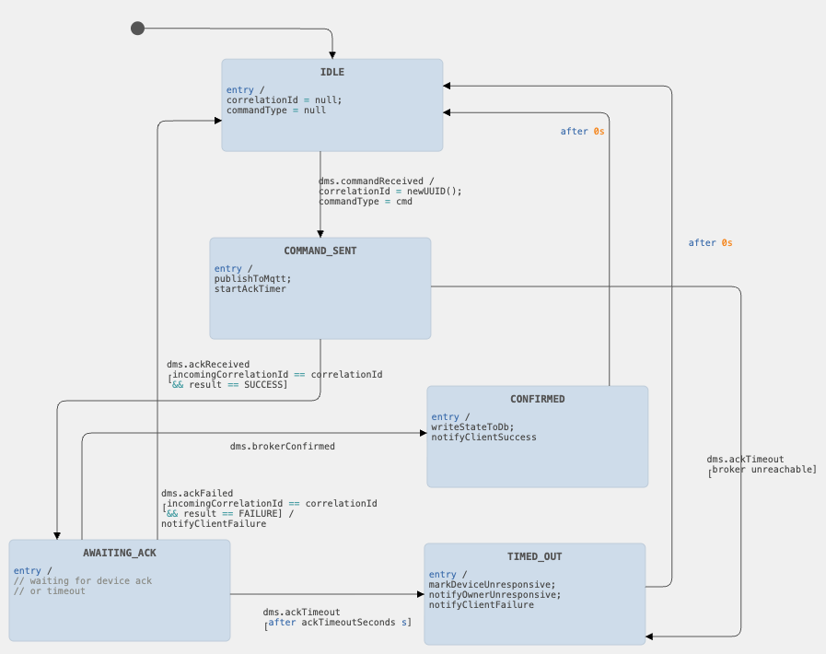
Lock_command_state_chart

The Lock Command state chart tracks the lifecycle of a single lock or unlock command from the moment it is dispatched to the device until it is confirmed, failed, or timed out.

States: IDLE, COMMAND_SENT, AWAITING_ACK, CONFIRMED, TIMED_OUT.
IDLE. No command is in flight for this device. The DMS is ready to accept a new lock or unlock request.
COMMAND_SENT. The DMS has published the LOCK or UNLOCK command to the device's MQTT topic. The correlationId has been recorded. The ack timeout timer has started.
AWAITING_ACK. The MQTT broker has confirmed it received the publish. The DMS is waiting for the device to respond on the ack topic.
CONFIRMED. The device has responded with a success ack containing the matching correlationId. The new lock state has been written to the DB. The client has been notified.
TIMED_OUT. No ack was received within the timeout window. The DMS marks the device UNRESPONSIVE, notifies the homeowner, and returns a failure to the client. The state machine returns to IDLE so a new command can be attempted.

Key transitions:
- IDLE -> COMMAND_SENT: lock or unlock request received, correlationId generated, command published to MQTT, timer started.
- COMMAND_SENT -> AWAITING_ACK: MQTT broker confirms publish.
- AWAITING_ACK -> CONFIRMED: ack received with matching correlationId and result SUCCESS, DB updated.
- AWAITING_ACK -> IDLE (failure): ack received with result FAILURE (e.g. actuator jam), error returned to client.
- AWAITING_ACK -> TIMED_OUT: timeout fires with no ack, device marked UNRESPONSIVE, homeowner notified.
- TIMED_OUT -> IDLE: state resets after notifying the client so future commands can be accepted.
- CONFIRMED -> IDLE: state resets after notifying the client.

Requests 3a and 3b: View Events / Watch Footage

Request 3a: View Event List
Content of request: deviceId, from timestamp, to timestamp, maxEvents, bearer token.
Desired response: A time-ordered list of SecurityEvent records for the specified device and time window. Each record contains event type, Lamport sequence number, occurred-at timestamp, and metadata. Camera-triggered events include a clipId indicating that footage is available.

Happy Path:
- Client Application opens the event history screen for a device and sends loadEventTimeline(deviceId, from, to, maxEvents) to the API Gateway with the bearer token.
- API Gateway validates the token via the User Management Service and routes to the Event Processing Service.
- Event Processing Service validates the parameters. From must be before to, maxEvents must be 1000 or fewer. It queries the Data Storage Layer async standby for events matching the deviceId and time window, ordered by Lamport sequence number ascending, capped at maxEvents.
- Data Storage Layer returns the matching event rows.
- Event Processing Service returns the event list to the API Gateway, which forwards it to the Client Application.
- Client Application renders the event timeline. Events with a clipId show a play button. Lock, unlock, and sensor-only events show metadata only.

Problems at each step
Step 2) API Gateway: token validation
- Token expired or revoked. UMS returns 401. Gateway forwards to client.
- All EPS instances are unhealthy. Gateway returns 503. Cluster Management Service restores capacity and client retries.

Step 3) Event Processing Service: query
- Parameter validation fails. from is after to, or maxEvents exceeds 1000. EPS returns 400 immediately without touching the database.
- Async standby is lagging. Slightly stale event history is acceptable for a historical query. The homeowner may not see the most recent few seconds of events but this is harmless. If the standby is unreachable, EPS falls back to the primary.
- No events found. EPS returns an empty list with 200 OK. The client shows an empty-state message.
- Result set too large. EPS enforces a maxEvents cap of 1000 and a certain MB response size limit.
DS issue: CAP Theorem: event history chooses availability. Reads go to the async standby to protect primary write throughput. Stale reads are acceptable here.
DS issue: Lamport Clocks: results are ordered by Lamport sequence number, not device-local timestamp. This guarantees consistent ordering regardless of device clock drift.

Step 4) Data Storage Layer
- Async standby unreachable. EPS falls back to the primary. Query succeeds with fully up-to-date results.
- Both primary and standby unreachable. EPS returns 503. Client falls back to a locally cached event list with a staleness warning.
DS issue: Data Replication: async standby serves read traffic. Primary and synchronous standby remain available as fallback.

Step 6) Client renders the timeline
- Client loses connectivity before response arrives. The request is read-only and idempotent so the client retries safely with no side effects.
- Client fully offline. Falls back to the locally cached event list with a staleness warning indicator.

Request 3b: Watch Footage for a Selected Event
Content of request: clipId (from the event's metadata), bearer token.
Desired response: A signed HTTPS URL the client uses to stream the video clip directly from the Data Storage Layer.

This request is triggered when the homeowner taps an event with a play button in the event list returned by Request 3a. The Video Streaming Service handles it entirely. The API Gateway is not in the video data path once the signed URL is issued.

Happy Path:
- Client Application sends openVideoPlayback(clipId) to the API Gateway with the bearer token.
- API Gateway validates the token and routes to the Video Streaming Service.
- Video Streaming Service calls findClips using the clipId to retrieve the clip metadata and storage key from the Data Storage Layer. It calls generateSignedPlaybackUrl(clipId, 3600) to produce a time-limited HTTPS URL.
- Video Streaming Service returns the signed URL to the API Gateway, which forwards it to the Client Application.
- Client Application initializes the video player and begins requesting chunks directly from the Data Storage Layer using the signed URL. The gateway is bypassed for all video data. The homeowner watches the footage.

Problems at each step
Step 8) API Gateway: token validation and routing
- Token expired or revoked. Returns 401. Client prompts re-login.
- All Video Streaming Service instances are unhealthy. Returns 503. Cluster Management Service restores capacity.

Step 9) Video Streaming Service: locating the clip
- Clip not found. The camera may have been offline when the event occurred and no footage was buffered locally, or the footage retention period has expired. Video Streaming Service returns 404. The client shows the event details without a playback option.
- Clip metadata read from async standby may be slightly stale. Acceptable since archived footage does not change after it is written.
DS issue: Data Replication: clip metadata is read from the async standby. The raw video bytes live in the Data Storage Layer and are streamed directly to the client using the signed URL.

Step 11) Client streams the footage
- Signed URL expires mid-playback. The client detects a 403 on the chunk request and silently fetches a fresh signed URL from the Video Streaming Service. Playback resumes without interruption.
- Insufficient bandwidth. The Video Streaming Service selects a lower quality tier based on the client's reported bandwidth. Quality is automatically upgraded when bandwidth improves.
- Client loses connectivity mid-playback. The player pauses. On reconnect, the client requests the next chunk. If the signed URL has expired, a new one is fetched transparently before resuming.
- The client is fully offline. Footage cannot be played. Video bytes are not cached locally. The client shows an error and prompts the homeowner to reconnect.
DS issue: CAP Theorem: video playback requires an active connection (availability). There is no offline fallback for footage since caching full video clips on the device is not practical.

Request 4: Motion Detection Alert (Device Triggered)
Initiator: Physical IoT device (motion sensor or camera). This request is not initiated by the homeowner.
Desired outcome: The security event is recorded with a Lamport sequence number, the homeowner receives a push notification, and the camera begins streaming and archiving footage for the duration of the motion. When motion stops, the stream is terminated and the footage is available for playback.

This flow has three concurrent paths that start from the Event Processing Service: the notification path, the stream-start path, and the archiving path.

Happy Path:

Phase 1: Event Detection and Ingestion
- Physical IoT device detects motion via hardware interrupt. The device's C firmware publishes a MOTION_DETECTED event over MQTT to the IoT Device Firmware service.
- IoT Device Firmware service receives the MQTT message, packages the event data (deviceId, eventType, occurredAt, metadata), and sends it as an HTTP POST to the Event Processing Service.
- Event Processing Service assigns the next Lamport sequence number (L = max(L, deviceTimestamp) + 1), enriches the event with ownerId and device display name by looking up the device in the Data Storage Layer, and persists the enriched SecurityEvent to the event history table. It then evaluates the alert criteria.

Phase 2: Parallel Paths (triggered simultaneously by EPS)
Path A) Notification: EPS fires a sendEventAlert call to the Notification Service asynchronously and does not wait for delivery confirmation.
- Notification Service looks up all push tokens registered to the owner. For each token it inserts a row into the pending_notifications outbox table, then dispatches the notification via APNs (iOS) or FCM (Android). On a confirmed 200 response from APNs/FCM, the row is marked SENT. If dispatch fails, the retry sweeper re-dispatches with exponential backoff.
- APNs / FCM delivers the push notification to the homeowner's device. The homeowner taps the notification and the Client Application opens to the event detail view.

Path B) Stream Start: EPS sends a startStream request to the Device Management Service.
- Device Management Service verifies the camera device is ONLINE, then sends a STREAM_START command to the IoT Device Firmware service via HTTP.
- IoT Device Firmware service receives the STREAM_START command and publishes it over MQTT to the physical camera.
- Physical camera begins capturing video and pushing the stream over MQTT to the IoT Device Firmware service.
- IoT Device Firmware service receives the video stream from the camera and forwards it over HTTP to the Video Streaming Service.
- Video Streaming Service buffers the incoming stream, applies adaptive bitrate transcoding, and writes video segments to the Data Storage Layer. The footage is now available for the homeowner to watch via Request 3b.

Phase 3: Motion Check and Stream Stop
- Device Management Service periodically sends isMotionDetectedNow queries to all sensors that originally triggered the event.
- IoT Device Firmware service forwards the query over MQTT to each physical sensor and returns the sensor's response to the DMS.
- Device Management Service collects responses. When all triggered sensors return noMotion, the DMS sends a STREAM_STOP command to the IoT Device Firmware service.
- IoT Device Firmware service publishes the STREAM_STOP command over MQTT to the camera. The camera stops capturing and the stream ends.
- Video Streaming Service finalizes the video segment, writes the completed VideoClip record to the Data Storage Layer, and closes the ingestion session.

Problems at each step
Phase 1: Event Detection and Ingestion
- Physical device is offline when motion is detected. The IoT Device Firmware service cannot receive the MQTT event. Motion goes undetected by the platform until the device reconnects.
- IoT Device Firmware service HTTP POST to EPS times out. The firmware service retries with the same idempotency key (hash of deviceId + eventType + occurredAt + nonce). The EPS deduplication table prevents the event from being stored twice.
- EPS leader is in the middle of a leader election. The EPS cluster is temporarily unavailable for writes. The IoT Device Firmware service queues the event locally and retries once the leader is re-established.
- EPS Raft replication fails to reach quorum before ack. The EPS does not acknowledge the event. The firmware service retries. Idempotency prevents duplicate storage.
DS issue: Idempotency: the idempotency key on the ingestEvent call prevents duplicate events from being stored on retry.
DS issue: Raft Log Replication: the EPS only acks the event after it is committed on a quorum of nodes, guaranteeing the event survives a single node failure.
DS issue: Lamport Clocks: the EPS assigns L = max(L, deviceTimestamp) + 1 as the sequence number, ensuring total ordering even if the device clock drifted

Phase 2 Path A: Notification
- Notification Service is temporarily unreachable. The EPS call is fire-and-forget so this does not block the stream-start path. The EPS logs the failure. The retry sweeper on the Notification Service leader will re-attempt dispatch when the service recovers.
- APNs or FCM returns a token-invalid error. The Notification Service marks the token INVALID, removes it from the registry, and does not retry for that token.
- APNs or FCM is temporarily unavailable. The pending_notifications row stays PENDING. The retry sweeper re-dispatches up to 5 times with exponential backoff. The APNs apns-id and FCM collapse-key idempotency keys prevent duplicate notifications if the retry succeeds after the platform had already delivered the first attempt.
DS issue: Idempotency: APNs apns-id and FCM collapse-key prevent duplicate push notifications on retry.
DS issue: Cluster Manager and Failure Detection: the Notification Service retry sweeper runs on the elected leader only, preventing duplicate dispatch from multiple nodes.

Phase 2 Path B: Stream Start
- Camera device is OFFLINE in the DMS registry. DMS does not send the STREAM_START command and logs the failure. The event is still recorded and the notification is still sent. The homeowner can view event metadata but no footage will be available.
- STREAM_START MQTT command is not acked by the camera. The IoT Device Firmware service retries the MQTT publish. If the camera remains unresponsive, the DMS marks it UNRESPONSIVE and sends a separate alert to the homeowner.
- IoT Device Firmware service crashes mid-stream. The Video Streaming Service detects the stream has stopped unexpectedly and finalizes the partial segment. The footage up to the point of the crash is preserved and available for playback.
DS issue: CAP Theorem: the stream-start path chooses availability. If the DMS cannot confirm the camera is online it skips the stream rather than blocking the notification path.

Phase 3: Motion Check and Stream Stop
- A sensor does not respond to the isMotionDetectedNow query. The DMS treats a non-response as motion still detected and continues streaming. The query is retried on the next polling interval.
- Motion is re-detected while the stream is running. Motion is re-detected on a sensor while the stream is already running. The DMS resets its motion-clear timer and continues streaming. No new SecurityEvent is created. The ongoing event remains open until all triggered sensors have returned noMotion. A single SecurityEvent covers the entire continuous motion window regardless of how many sensors fired or re-fired during it.
- STREAM_STOP command is not acked by the camera. The IoT Device Firmware service retries the MQTT publish. The camera will eventually stop streaming when its own local timeout fires, even if the explicit stop command is lost.
- Video Streaming Service fails to finalize the clip. The partial footage already written to the Data Storage Layer is preserved. The clip metadata record may be incomplete. The DMS logs the failure.
DS issue: Cluster Manager and Failure Detection: the DMS heartbeat monitor tracks camera liveness. An unresponsive camera during the motion check is treated as still-active to avoid prematurely stopping the stream.

There are 3 state charts for this request: Motion Event State, Stream State, and Notification Delivery State

1) Motion Event
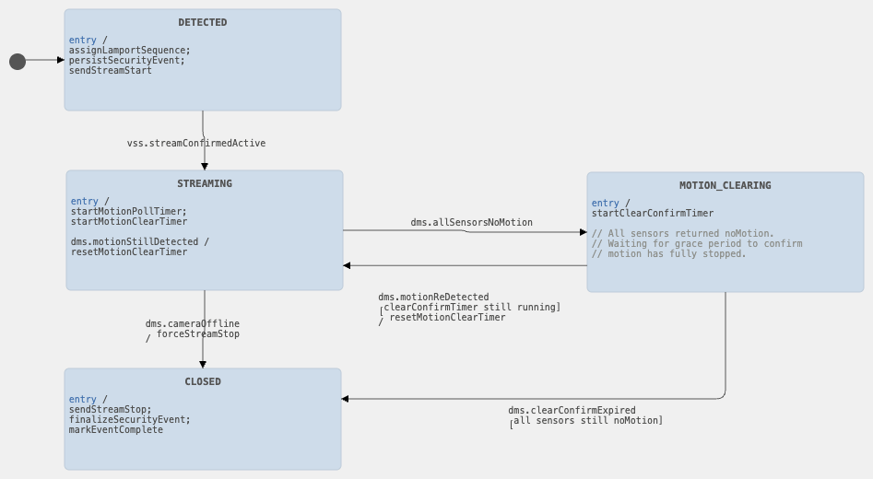
Motion_event_state_chart

The Motion Event state machine tracks the lifecycle of a single motion detection event from the moment the physical sensor fires until the stream is stopped and the event record is finalized. It runs in the Device Management Service.

States: DETECTED, STREAMING, MOTION_CLEARING, CLOSED
DETECTED:The EPS has assigned a Lamport sequence number, persisted the SecurityEvent, and sent STREAM_START to the camera.
STREAMING: The stream is active. The DMS is polling sensors on a fixed interval. No new SecurityEvent will be created while in this state regardless of how many sensors fire.
MOTION_CLEARING: All sensors returned noMotion. A grace period timer is running to confirm motion has fully stopped before the event is closed.
CLOSED: Grace period expired with no re-detection. STREAM_STOP sent, event record finalized, clip ready for playback.
Key transitions:
- DETECTED -> STREAMING: Video Streaming Service confirms first chunk received and stream is active.
- STREAMING -> MOTION_CLEARING: all polled sensors return noMotion in the same polling round.
- MOTION_CLEARING -> STREAMING: any sensor re-detects motion before the grace period expires. Motion-clear timer reset. Same event continues
- MOTION_CLEARING -> CLOSED: grace period expires with all sensors still reporting noMotion.
- STREAMING -> CLOSED: camera goes OFFLINE or DMS forces a stop. Event closed early, partial clip preserved.

2) Stream State
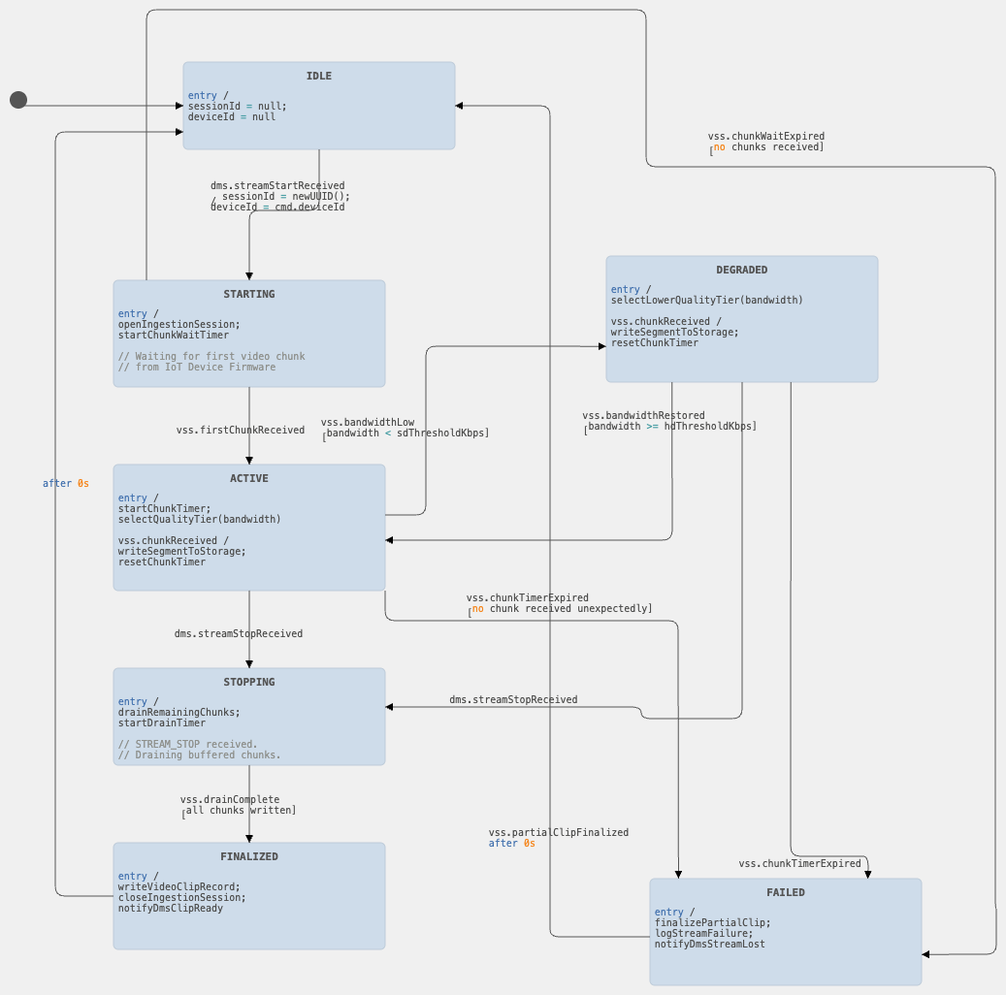
Stream_session_state_machine

The Stream Session state machine tracks the lifecycle of a single video stream from STREAM_START through to clip finalization or failure. It runs in the Video Streaming Service.
States: IDLE, STARTING, ACTIVE, DEGRADED, STOPPING, FINALIZED, FAILED.
IDLE: No stream in progress. Ready to accept a new STREAM_START command.
STARTING: Ingestion session opened. Waiting for the first chunk from IoT Device Firmware.
ACTIVE: Stream live. Chunks being written to storage at the current quality tier.
DEGRADED: Chunks still arriving but bandwidth dropped below threshold. Lower quality tier selected, stream continues uninterrupted.
STOPPING: STREAM_STOP received. Draining remaining buffered chunks before closing the session.
FINALIZED: All chunks written. VideoClip record complete. DMS notified clip is ready.
FAILED: Stream lost unexpectedly without a STREAM_STOP command. Partial clip preserved.

Key transitions:
- IDLE -> STARTING: DMS sends STREAM_START. A new session ID is generated.
- STARTING -> ACTIVE: first video chunk received from IoT Device Firmware.
- STARTING -> FAILED: chunk-wait timer expires with no chunks received. Camera did not respond to the STREAM_START command.
- ACTIVE -> DEGRADED: client bandwidth drops below the SD threshold. Lower quality tier selected.
- DEGRADED -> ACTIVE:client bandwidth recovers above the HD threshold. Higher quality tier restored.
- ACTIVE -> STOPPING: STREAM_STOP command received from DMS.
- DEGRADED -> STOPPING: STREAM_STOP received from DMS.
- STOPPING -> FINALIZED: all buffered chunks written, VideoClip record complete.
- ACTIVE -> FAILED: chunk timer expires unexpectedly.
- DEGRADED -> FAILED: chunk timer expires unexpectedly.
- FAILED -> IDLE: partial clip finalized, session reset.
- FINALIZED -> IDLE: session reset, ready for next stream.

3) Notification Delivery
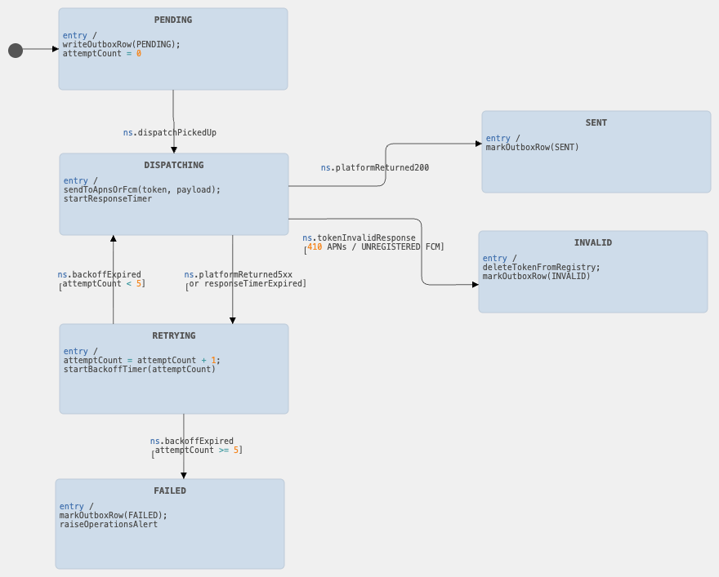
Notification_delivery_state_chart

The Notification Delivery state machine tracks the lifecycle of a single push notification from the moment it is queued in the outbox until it is confirmed delivered, permanently failed, or marked invalid. It runs on the Notification Service leader node.

States: PENDING, DISPATCHING, SENT, RETRYING, FAILED, INVALID.

PENDING: The notification has been written to the pending_notifications outbox table but has not yet been dispatched to APNs or FCM.
DISPATCHING: The Notification Service has sent the payload to APNs or FCM and is waiting for their HTTP response.
SENT: APNs or FCM returned a 200 response. The notification was accepted for delivery. The outbox row is marked SENT.
RETRYING: APNs or FCM returned a 5xx or timed out. The retry sweeper will re-dispatch after an exponential backoff delay (30s, 1min, 2min, 4min, 8min). The attempt count is incremented.
FAILED: The notification has been retried 5 times with no success. The outbox row is marked FAILED and an internal operations alert is raised.
INVALID: APNs or FCM returned a token-invalid response. The token is removed from the push token registry and the outbox row is marked INVALID. No further retries are attempted.

Key transitions:
- PENDING -> DISPATCHING: retry sweeper or initial dispatch picks up the outbox row and sends the payload to APNs/FCM.
- DISPATCHING -> SENT: APNs/FCM returns 200. Row marked SENT.
- DISPATCHING -> RETRYING: APNs/FCM returns 5x or request times out. Attempt count incremented. Backoff timer started.
- DISPATCHING -> INVALID: APNs/FCM returns token-invalid (410 from APNs, UNREGISTERED from FCM). Token deleted from registry. Row marked INVALID.
- RETRYING -> DISPATCHING: Backoff timer expires and attempt count is below 5. Retry sweeper re-dispatches.
- RETRYING -> FAILED: Attempt count reaches 5. Row marked FAILED. Operations alert raised.

.

